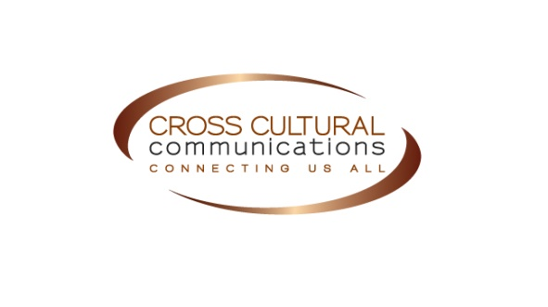

REGISTRATION FORM

Please complete one form for each program after reading the policies and procedures below. Then email or mail the registration form. Payment must arrive no later than the scheduled due date (see training calendar for details). For questions, call 410.312.5599. Please make out checks to: Cross-Cultural Communications, LLC. Send forms and checks to:

Cross-Cultural Communications, LLC
10015 Old Columbia Road, Ste. B-215
Columbia, MD 21046
Email: mateem@cultureandlanguage.net

Participant Name:_________________________________

Job Title: ____________________________________________________________________

Organization Name: ____________________________________________________________

Address: _____________________________________________________________________

City/State/Zip: ________________________________________________________________

Phone: ______________ Fax: _______________ Email: _______________________________

Program title/Date(s): _ ___ Fee: _______

Languages spoken besides English (if applicable): ____________________________________

Other training(s) attended (if applicable): ___________________________________________

PLEASE PRINT CLEARLY! THANK YOU.

Training Registration Policies and Procedures: please carefully review the following, which includes important information about payment, refund and cancellation policies:

Registration and payment
Public trainings offered by CCC feature a deadline for payment and registration effective two weeks prior to the start of the training. Full payment is due at that time in order to reserve a place in the training program. Space for our programs is filled on a first-come, first-paid basis.

Confirmation of registration
Upon receipt of online payment for a training registration, within 2-3 business days an email confirmation will be sent to the customer.
Approximately two weeks before the first day of a training program, a welcome email will be sent to all training participants. This welcome email will reconfirm the training location, date(s), time(s) and include further information such as trainer bio(s), contact telephone number(s) and item(s) that participants should bring to the training.
Approximately 2-3 days before the training, a final reminder email will be sent to training participants.

Refunds and credits
A refund request for a training program fee must be submitted in writing to Maisoon Ateem Abdelrhman, Program Manager at: mateem@cultureandlanguage.net. Refund requests submitted before the two-week training registration deadline will be subject to a $50 cancellation fee. Refund requests submitted in the two-week period from the day of the registration deadline up until 11:59PM of the day before the training will be subject to a cancellation fee in the amount of 50% of the training program fee. Refunds will not be given after this deadline. Rather, a credit may be issued upon request submitted within two weeks of the first day of the training program, meaning that in the event of being unable to attend a program, a participant may submit a written request to apply that training program fee to a future program. If approved by CCC, this amount will be kept on file as a credit for up to 2 years, after which the amount will be forfeited.

Cancellations
In the event of a training program cancellation, CCC will communicate this information to training participants as quickly as possible. Training participants can either request a refund or apply the training registration fee as a credit toward a future program.

Registration is also available at www.cultureandlanguage.net.
Click on “TRAINING,” then select the appropriate training from the list and register.

